**Click Here: [Introduction To Tinikling Presentation](http://vimeo.com/52667544" \t "_top)**.

Tinikling

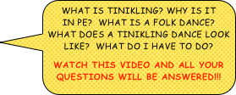

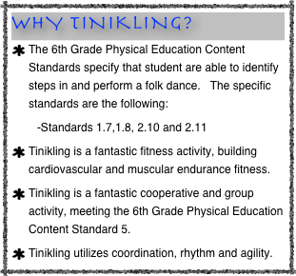

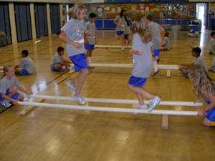

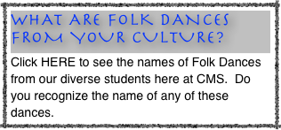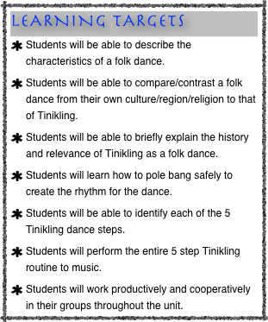

DOWNLOADS FOR UNIT:

You will find these handouts under Tinikling downloads. You need to print out the Tinikling Packet and put it behind your Unit Tab.

Handout # 1

Handout #2

Handout # 3

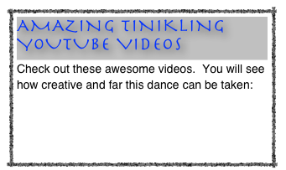

Great Theater Performance:

<http://www.youtube.com/watch?v=oCUEeSIVCxU&feature=em-share_video_user>

Micheal Jackson Mixed Performance:

<http://www.youtube.com/watch?v=asgQ4lWug3s&feature=em-share_video_user>

Greatest Tinikling Dance Team in World:

<http://www.youtube.com/watch?v=2IK838WNEVA&feature=related>

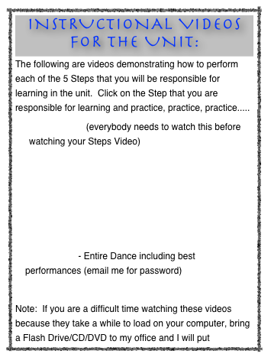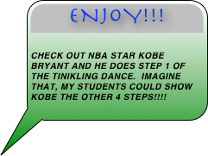

Click the link below to see different Folk Dances from around the world.

<https://www.youtube.com/user/zaixega>

njoy!!!

Check out Nba star kobe bryant and he does step 1 of the tinikling dance.  imagine that, my students could show kobe the other 4 steps!!!!



Step One: Side to Side- <http://www.vimeo.com/15290933>

Step Two: Diagonal Step- <http://www.vimeo.com/1529110>

Step Three: Travel Step- <http://www.vimeo.com/15291244>

Step Four: Jump/Hop Step: <http://www.vimeo.com/15291480>

Step Five: Forward & Back:

<http://www.vimeo.com/15296507>

http://www.youtube.com/watch?v=dJZ3E6BuPtw